Data Migration Tool

Last Updated: 11/21/2022

Latest Version: Data Migration v9.1

Author: Emanuel Baca

To receive the latest version, click on the link below or email Emanuel.Baca@ul.com

[Ops Team - information - Data Migration Tool - All Documents (sharepoint.com)](https://ul.sharepoint.com/sites/int2224/Shared%20Documents/Forms/AllItems.aspx?id=%2Fsites%2Fint2224%2FShared%20Documents%2FData%20Migration%20Tool&viewid=a087a12f%2D4a9e%2D4901%2Db47f%2Da0c835d545e6)

Latest Addition(s):

Version 9.1 (12/8/22)

* Resolved an issue where SharePoint Folders were being copied due to the folder: “Underwriters Laboratories” was being copied over; path is now excluded so will not copy contents anymore

Additions of Version 9 (11/21/22)

* Hidden options 5 and 6 are added for the event that the tech needs to backup or restore from a SPECIFIC Drive such as a network drive for example, works the same as options 3 and 4. Just confirm the Drive Letter and let the program do the work: **Option 5 is backup and Option 6 is restore**
* List of local user profiles now are displayed for ease so you can see the targeted user’s employee id
* Hard drive space is now displayed, as well as any external hard drives with the assigned letters D or E

Additions of Version 8 (10/20/22)

* Implementation of a User Profile Scan, copies Unique Folders under User’s Profile (both OneDrive and External)
* Unique Profile Folders are now restored using an External Drive (not using OneDrive)
* Copying of all Microsoft Application App Data and restores it as well (both OneDrive and External) *Refer to the Xcopy List on pages 9 and 10 for paths added*
* Program now checks if E drive exists since sometimes our External Drives map to E, you can now specify and confirm external data backup locations if this occurs
* OneNote, Network Drives, and Task Bar Registry files are now exported and imported (both OneDrive and External)

# Instructions:

***This tool does not require admin privileges and is*** ***run under the User’s account. Failing to do this results in fatal program errors when making new directories and exporting/importing User Specific Registries.***

The tool can be used in the following ways:

* On a Network Drive
* On an External Drive
* On the User’s local system (You can ping the User the Batch file and they are able to download it, it does not matter where it is stored, typically it is downloaded so it would reside in the downloads folder)

# Option(s) Instructions:

Option# 1: “Backup User Data (OneDrive)”

* Requirements: ***Target System*** ***MUST HAVE 45gbs > FREE ON C Drive***, I cannot guarantee that the program will back up all the data to OneDrive properly because of the temporary space needed to upload the data to the cloud. First, verify that their OneDrive is set up and is signed in so that the data can be uploaded to the cloud. The OneDrive setting “Always keep on this device” ***MUST*** ***BE TURNED OFF***, failure of doing so will **DUPLICATE ALL DATA** on User’s hard drive! ***It is HIGHLY RECOMMENDED to use OneDrive to back up/******sync the Desktop, Documents, and Pictures. To do this navigate to OneDrive in the taskbar, right click and select “Settings” go to the “Backup” tab at the top, select “Manage Backup” then start backing up all three folders. You must wait till OneDrive completes its backup before running the batch program!***
* After Backup is completed, the Tech is **REQUIRED** to backup any Unique folders under C:\ and save them under the folder called “C_Drive” under DataBackup located in OneDrive, this is the only additional step required.

Option# 2: “Restore User Data (OneDrive)”

* Requirements: On the new system, wait until all the data has been uploaded to the cloud on the old system (you can check this by making sure that the OneDrive icon on the bottom right on the taskbar says, “up to date”). Upon signing into the new system, you must wait till OneDrive processes all the changes and says, “up to date,” then you are now able to run the program to restore all the User’s Data.
* After the Restore is completed, the Tech is **REQUIRED** to restore all the data in C_Drive folder to C:\ and Profile Folders to C:\Users\UsersID\. Due to OneDrive complications, the script is unable to perform these actions.

Option# 3: “Backup User Data (External (D:) Drive)”

* Requirements: Save the batch file to the external drive (is not needed but is recommended), make sure you have sufficient free storage space before continuing. The program assumes that the connected drive it assigned the Letter D, however it does double check to make sure that if a letter E exists, it will prompt the Tech to enter the Letter of the external drive, it is not case sensitive so enter just the letter of the drive and you are good to go.
* No more steps required from the Tech

Option# 4: “Restore User Data (External (D:) Drive)”

* Requirements: Plug in the external drive with the backed-up data then just run the program, nothing else needed. Again, the program assumes that the external drive is mapped to letter D, the restore option does NOT check if it exists or not so, please make sure that the drive is assigned the letter D.
* After the Restore is completed, the Tech is **REQUIRED** to restore all the data in the C_Drive folder to C:\. The reason for this is the local user credential issues, typically when restoring C:\ contents you are prompted for Admin Credentials. Please also confirm that profile folders are restored correctly by the program, this is all that is needed, and you are all set.

Option# 5: “Backup User Data (Specific Drive Letter)”

* Requirements: If using a network drive, please make sure that the user has read AND write access or else the program will FAIL. Follow the program prompts and everything should work as intended. You will need to confirm the drive letter then enter it into the program

Option# 6: “Restore User Data (Specific Drive Letter)”

* Requirements: If using a network drive, please make sure that the user has read AND write access or else the program will FAIL. Follow the program prompts and everything should work as intended. You will need to confirm the drive letter then enter it into the program.
* After the Restore is completed, the Tech is **REQUIRED** to restore all the data in the C_Drive folder to C:\. The reason for this is the local user credential issues, typically when restoring C:\ contents you are prompted for Admin Credentials. Please also confirm that profile folders are restored correctly by the program, this is all that is needed, and you are all set.

# Example Run of Program:

Now logged in as the User, launch the tool and you should be welcomed by the following screen:

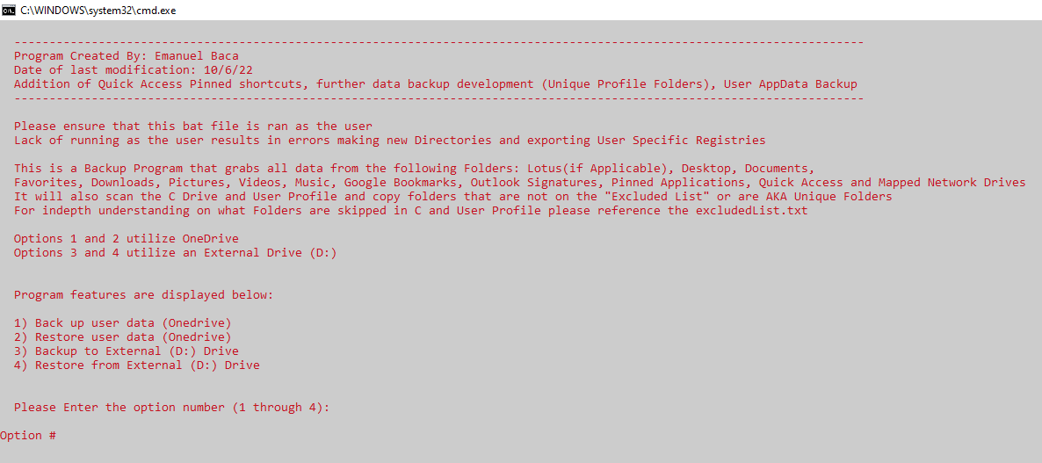

Here select your desired option and you will be followed with a prompt asking for the User’s Employee ID, enter the User’s Employee ID NUMBERS ONLY ex. 82237. This is all that is needed to start the program, you do not need to be present when this is running as there is no input needed from you.

After the program has finished its processes, you will be greeted with a backup Log or a restore Log to indicate that it has run successfully. Here you can just do a quick skim to confirm that all the data was either backed up or restored. Example of a successful program execution is below: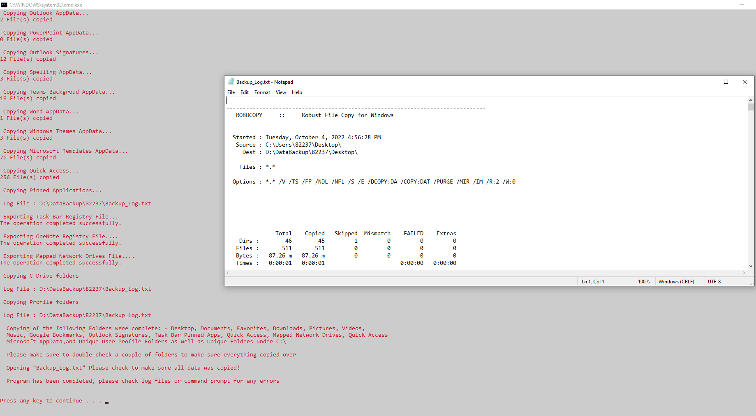

*In this example, Option# 3 was used*

*It is always a good practice to check a couple of folders and verify that contents were successfully transferred over before deploying it to the end user.*

# Common Questions/Issues:

1. When restoring using Option# 4, restoring Profile Folders shows “Access Denied” but program completed anyways? Example of error below:

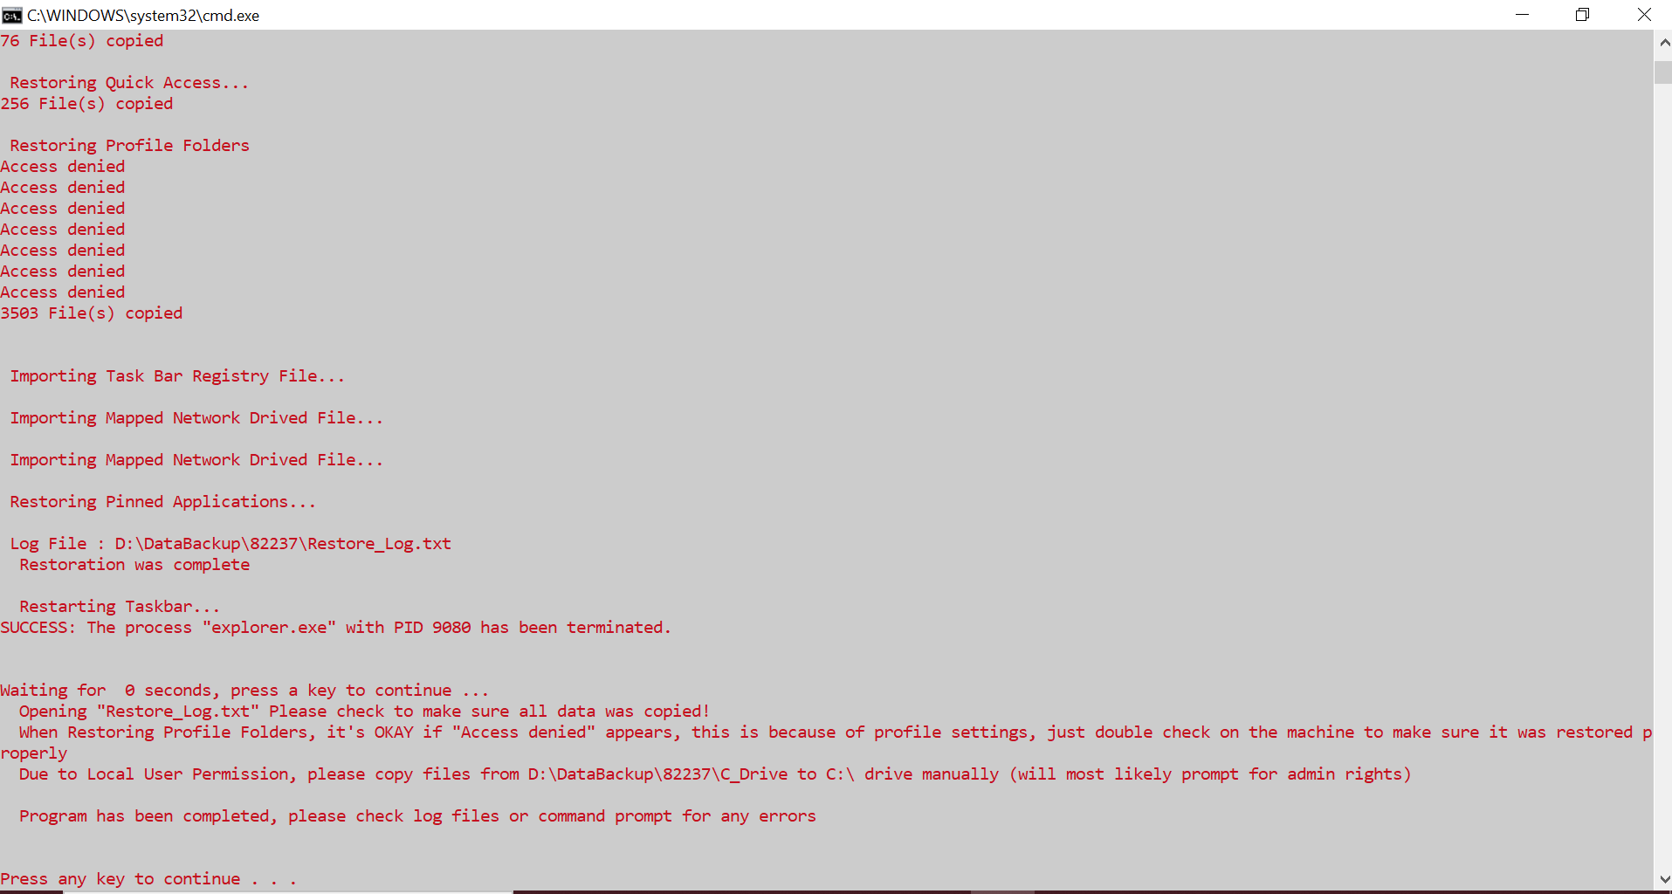

**Answer:** This is completely normal and okay, the reason for the “Access Denied” is due to some individual system files or folders such as IntelGraphicSettings or the odd system files as #3AFE2E0.xls, .pptx, .doc and .jpeg. Make sure to double check the restored profile folders just to confirm that Profile Folders contents were restored.

1. Restoration is completed but Edge and Chrome did not get pinned to the taskbar or pinned applications icons are not visible? Example of pinned app icon error



**Answer:** Unfortunately, due to the security and lockdown that Windows has, this is an error than cannot be addressed in the program. To resolve it, you will have to manually unpin and re-pin the program to restore program icon or missing pinned apps.

1. Why does “A subdirectory or file D:\DataBackup already exists” error show up on the command line”? Example shown below:

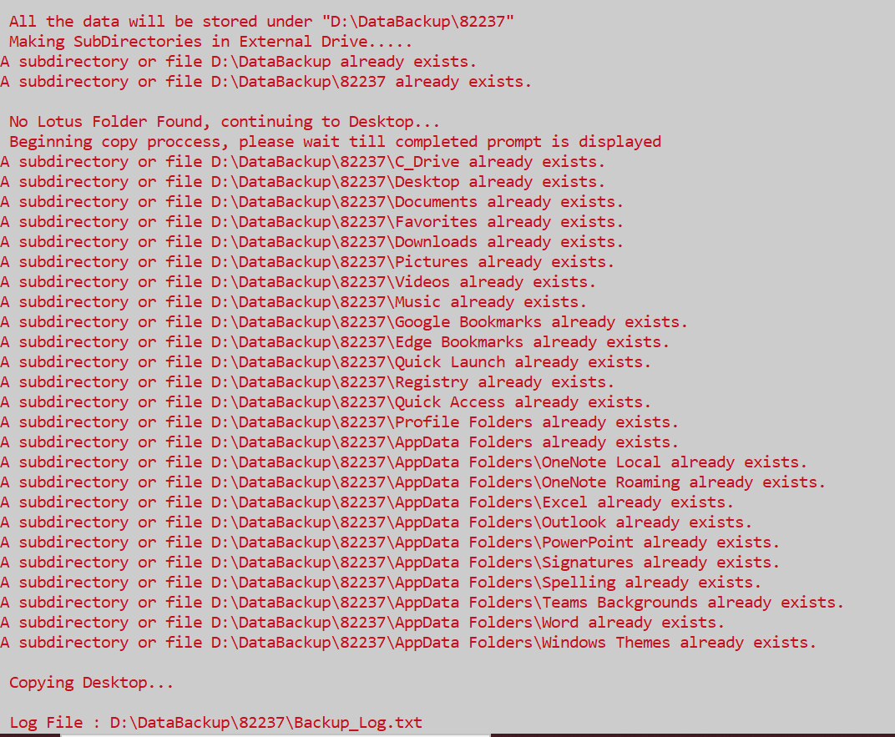

**Answer:** This is normal, it is just telling you that there are already folders created from a previous backup or restore. It is not an error and is to be dismissed.

1. Program is stuck on a Copy/Restore line for a long amount of time?

**Answer:** This is a rare occurrence, but you can hit the spacebar once or twice and you should see the program progress as normal. The other case is that the folder it is copying is quite large and can take some time, you can confirm this by checking on the destination on Data backup and see if there are new files appearing.

1. The program restored everything successfully, but the desktop and documents folder are all empty?

**Answer:** This typically means that the Desktop and Documents folders are pointing to OneDrive – Underwriters Laboratories. To resolve this inconvenience, navigate to the OneDrive icon in your taskbar, right click and select settings.

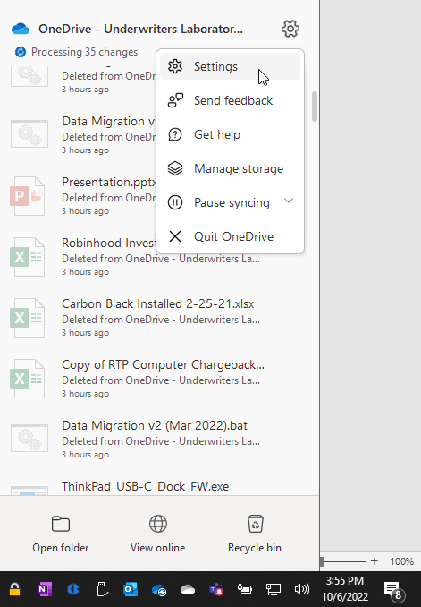

Upon clicking Settings, you will see another box appear, navigate to the “Backup” tab at the top and select “Manage backup”

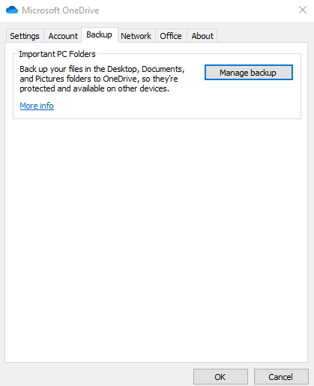

After selecting “Manage backup,” you will arrive at the following screen:

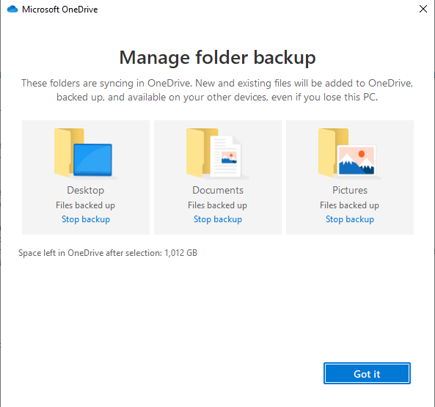

Here, select “Stop backup” for all the folders: Desktop, Documents and Pictures. Close it out and you should see your Desktop, Documents and Pictures populate as you expected them to. Now the folders are pointed to the local C drive and the issue is resolved.

1. I ran the program, and it finished fast, and nothing happened? This can occur upon a backup/restore. Pictures shown below:

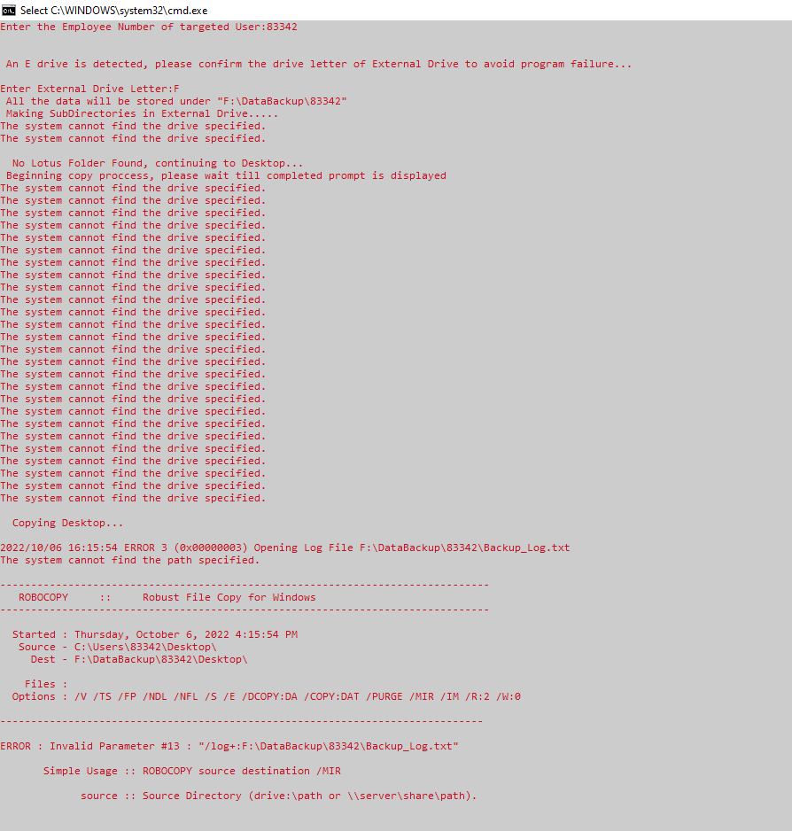

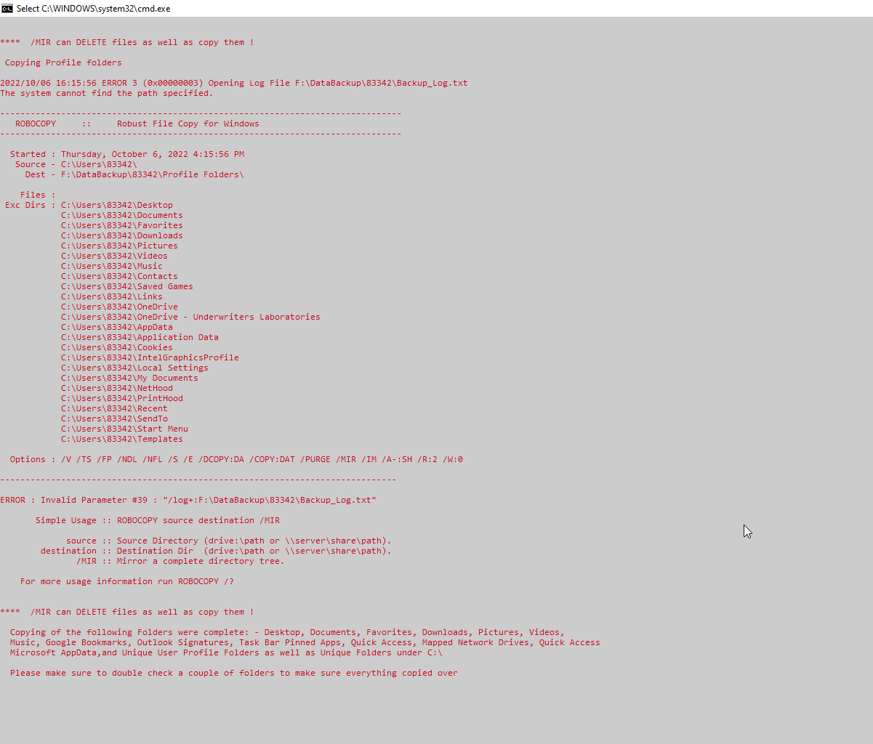

**Answer:** This typically comes down to a syntax error such as entering the User’s Employee ID incorrectly or an External Drive not being detected. Please make sure to verify the User’s Employee ID and if the External Drive is connected properly. By default, the External Drive Letter is set to D in the program, if it is under the Letter E, you will receive a prompt from the program to verify the External Driver Letter, enter in the External Driver Letter (either lowercase or uppercase) and you should be all good to go.

# Contents of Backup and Restore Log Files

Due to the complications of some data and folders playing nice and others not so much, I resorted to using both Xcopy and robocopy in the program. Only robocopy commands have the capability to log the actions while Xcopy is shown in the command prompt.

**Xcopy commands:**

Xcopy "%src%:\Lotus\Notes\notes.ini"

Xcopy "%src%:\Users\%USERID%\AppData\Local\Google\Chrome\User Data\Default\Bookmarks"

Xcopy "%src%:\Users\%USERID%\AppData\Local\Microsoft\Edge\User Data\Default\Bookmarks"

Xcopy "%src%:\Users\%USERID%\AppData\Local\Microsoft\OneNote"

Xcopy "%src%:\Users\%USERID%\AppData\Roaming\Microsoft\OneNote"

Xcopy "%src%:\Users\%USERID%\AppData\Roaming\Microsoft\Excel"

Xcopy "%src%:\Users\%USERID%\AppData\Roaming\Microsoft\Outlook"

Xcopy "%src%:\Users\%USERID%\AppData\Roaming\Microsoft\PowerPoint"

Xcopy "%src%:\Users\%USERID%\AppData\Roaming\Microsoft\Signatures"

Xcopy "%src%:\Users\%USERID%\AppData\Roaming\Microsoft\Spelling"

Xcopy "%src%:\Users\%USERID%\AppData\Roaming\Microsoft\Teams\Backgrounds"

Xcopy "%src%:\Users\%USERID%\AppData\Roaming\Microsoft\Word"

Xcopy "%src%:\Users\%USERID%\AppData\Roaming\Microsoft\Windows\Themes"

Xcopy "%src%:\Users\%USERID%\AppData\Roaming\Microsoft\Templates"

Xcopy "%src%:\Users\%USERID%\AppData\Roaming\Microsoft\Windows\recent"

* These processes will NOT be visible in the Backup Log/Restore Log, so pay attention to the command prompt if you are looking for confirmation that they were copied/restored properly

**Backup robocopy commands:**

robocopy "%src%:\Users\%USERID%\Documents"

robocopy "%src%:\Users\%USERID%\Favorites"

robocopy "%src%:\Users\%USERID%\Downloads"

robocopy "%src%:\Users\%USERID%\Pictures"

robocopy "%src%:\Users\%USERID%\Videos"

robocopy "%src%:\Users\%USERID%\Music"

robocopy "%src%:\Lotus\Notes\Data"

robocopy "%src%:\Users\%USERID%\AppData\Roaming\Microsoft\Internet Explorer\Quick Launch"

robocopy %src%:\

robocopy %src%:\Users\%USERID%\

* These on the other hand appear in the Backup Log/Restore Log so feel free to confirm data transfer status there.
* The only difference with the restore log is that Profile Folders are restored using Xcopy so there is no log file for that.

# Folders Excluded from C Drive and User Profile Scan

**C Drive Scan Exclusion List:**

"C:\Program Files (x86)"

"C:\Program Files"

"C:\Oracle11G"

"C:\OneDriveTemp"

"C:\PerfLogs"

"C:\Users"

"C:\Win-builds"

"C:\Windows"

"C:\boot"

"C:\Intel"

"C:\ProgramData"

"C:\CheckPoint"

"C:\Lotus"

"C:\$Windows.~WS"

"C:\$Recycle.Bin"

"C:\Recovery"

"C:\Documents and Settings"

"C:\ESD"

"C:\System Volume Information"

**User Profile Scan Exclusion List:**

"C:\Users\%USERID%\Desktop"

"C:\Users\%USERID%\Documents"

"C:\Users\%USERID%\Favorites"

"C:\Users\%USERID%\Downloads"

"C:\Users\%USERID%\Pictures"

"C:\Users\%USERID%\Videos"

"C:\Users\%USERID%\Music"

"C:\Users\%USERID%\Contacts"

"C:\Users\%USERID%\Saved Games"

"C:\Users\%USERID%\Links"

"C:\Users\%USERID%\OneDrive"

"C:\Users\%USERID%\OneDrive - Underwriters Laboratories"

"C:\Users\%USERID%\AppData"

"C:\Users\%USERID%\Application Data"

"C:\Users\%USERID%\Cookies"

"C:\Users\%USERID%\IntelGraphicsProfile"

"C:\Users\%USERID%\Local Settings"

"C:\Users\%USERID%\My Documents"

"C:\Users\%USERID%\NetHood"

"C:\Users\%USERID%\PrintHood"

"C:\Users\%USERID%\Recent"

"C:\Users\%USERID%\SendTo"

"C:\Users\%USERID%\Start Menu"

"C:\Users\%USERID%\Templates"

Any of the following listed folders are AUTOMATICALLY SKIPPED by the program, if for whatever reason there are more folders that should skipped, please let me know and I can add them to the scanner lists. If for whatever reason you need to copy some data in the specified folder, you must do that manually.

These folders are skipped for two reasons:

* They are system files which should NOT be copied over or require admin credentials
* They are skipped to prevent data being copied TWICE, once by the specified path by Xcopy or robocopy and another time by the scanner copy, hence why the paths are put on the excluded lists to skip them

The scans are performed at the end of the program to just pick up whatever other Unique Folders are founds.

*If there are any questions or issues, please get ahold of Emanuel Baca either via teams or via email Emanuel.Baca@ul.com*